NONFICTION: Travelling
I remember the 7th time I visited Machu Picchu I happened to walk by a group of llamas and the weight of the world fell unto my shoulders. I guess it felt a bit surreal that this furry giraffe-pony thing that’s practically synonymous with the location was, in fact, really…well…there. That all those pictures of Machu Picchu at the level of clouds visible over the shoulder of some llama with crooked teeth weren’t just staged by some Peruvian tourism marketing team. (At least, not all of them.) And that this place—or any place that one could visit, for that matter—really could just be what one expected it to be. I had heard some who travel even more than I do talk about how disappointed they felt when they visited some grand royal palace housing centuries of history and war and culture and society only to come back home to their couch, in some boxers and a plain white tee with a stain from last week’s BBQ burger, to switch on the television feeling like the same, old person; feeling just as ancient as the palace.
And that’s how I was feeling as I looked at these llamas in Machu Picchu…I could have guessed this much. I could have imagined Machu Picchu just as accurately. Could it also be more than this? Or was it just a place. Like my hometown is a place. Like my house or my bedroom is a place. If some stranger visited my home, then they probably wouldn’t know what to expect. Does that make it more interesting than Machu Picchu?
For someone as well traveled as myself, I should know the answer to that reverie. Or at least I should have the wisdom from traveling across the globe to look at anyone who unironically wrote those words onto this page and slap them across the face. But I’m not sure I do. Then again, to be fair, the kind of traveling I do isn’t physical. I do this kind of traveling. Or this kind. And this too. Wait, no. That was the wrong one, sorry. I meant this one. Is it the same life-altering experience? Probably not, no. But it’s definitely cheaper.
Not to mention, I can time travel this way. I can wake up at two in the morning needing to go to the bathroom because I drank too much water before heading to bed again like an idiot, reluctantly get up to go, and then walk back to my room, get a pang of midnight inspiration, and see how the sunrays bounce off of the blinding white of the Cliffs of Dover even as moon rays shine into my room. And it’s nice to have views like that one that I couldn’t have in real life. And to be able to see the same tourists frozen in place every time like an old friend. Man in Red Shirt #3 and Girl in Blue Jacket #2.
It all started off real simple. My mom had to go somewhere. I think it was some doctor’s office that she’d never been to before. She gets lost easily, and it doesn’t help that she only speaks Spanish so giving her directions based on street names or businesses is more confusing than helpful. But I had the ingenious idea of pulling up the address on Google Earth and then showing her where she was going using the Street View. That way she could have a mental picture of the course and of what the location looked like on the outside. She’s not very familiar with technology, so I remember her surprise at this fascinating feature. But I have to admit that the novelty of it caught my eye too.
The place was relatively close to home. So, after my mom took off I decided to try to visit my house using Google Earth too. As you can see, I found that it was almost completely obscured by two trees in the front yard that have since been cut down. I could immediately tell this was an old picture. After moving the camera a bit, I could see that the car in the garage was not even ours. Meaning this was taken years ago before we moved in when I was in the 7th grade. Sitting at my desk, I looked out the window at the yard and spent a few mins appreciating how the house had changed with our presence; the flowers my mom had planted, all the décor she’d put up—the plastic flamingos and solar powered pathway lights.
And all of that made me think of where we used to live. That trailer park in Edinburg. Could I visit it too? Yea, I could. With one caveat: it seemed there were limits to this technology. I could only look at the trailer park’s entrance, but not travel into it. Whatever device Google used to get this data—the Google Car or whatever—hadn’t driven into the park. It probably didn’t seem that important. As a result, I couldn’t run down the streets like my 10-year-old self to the lot where our old trailer home with the red and white paint peeling off used to stand. I couldn’t look for the old, decaying red bench where I had sat when the wasps in the nests above it stung me five times. I couldn’t look around at the other lots to try to recall the old homes of the friends I’d visit to play video games with. And I couldn’t entertain the curiosity of whether the gray 1990-something Ford Mercury with the broken A/C system could be found somewhere in this dated snapshot of the trailer park. I remember my mother and I sharing a cheap, mini fan—one of those you could hook up inside the car—during the hot Texan summers as she took me with her to work because she didn’t have the money for a nanny or a daycare. It didn’t help much, we still arrived drenched in sweat.
But despite Google Earth failing me in this desire to visit my childhood home and the neighborhood with all those friends, I was still hooked. From there I started exploring the rest of the city a bit, then the state, then the country and more. I even opened up a list of the Seven Wonders of the Ancient World along with the Seven Wonders of the Modern World. The coordinates for each location were listed on there too. I’ve never considered myself much of a history or culture buff. I never even took a world history class—which is embarrassing to say the least. But my interest was certainly there. Perhaps because of this void of historical and cultural knowledge that I wanted to fill, I got into the habit of reading a few sentences on the background of a significant site, and then copy pasting its coordinates into the search bar and pressing enter. Then, the camera would cinematically zoom out, pan to the region of the globe I had directed it towards, and then zoom in so that I’d arrive a million times faster than any flight.
I got lost in this cycle of zooming in and out of new locations in the world for so long that when I stopped to do something else it felt like a mere break from the real mission of my day. And though I’d shifted from seeing it from mindless entertainment to fun, and educational virtual tours, its real power wouldn’t be apparent to me until I shared it with my mom.
When I’m back home, every night my mom and I sit on the couch and watch a TV show together. Most of the time it’s some game show or some stand-up or sitcom. But one night during the commercial break, I grabbed my laptop and started traveling around again. With my mom by my side, I figured I’d get her interested too and showed her how we could see our own home using it, and how we could visit the trailer park where we used to live too.
“Can you go to Reynosa?” she asked, referring to the city in Tamaulipas, Mexico where she grew up.
“Yea, I should be able to.” I said, as I entered “Reynosa, Tamaulipas” in the search bar and arrived in the city within seconds.
“You know, that’s really close to where I used to live. Keep going that way. Look for Calle Occidental.” she said, pointing me down the streets she remembered walking early in the mornings before the sun had risen to get to school and late at night to return home from work. It was a routine she had kept up for as long as she could. Until eventually, the financial burdens her single mom and siblings were facing grew too heavy, and she had to focus entirely on working to support them. She picked up a full-time job at a maquiladora, a factory where American materials were shipped across the border to be cheaply assembled into a finished product that was then sent back to the US. In my mom’s case, she worked for 15 years at a Zenith factory, assembling TVs and other electronics before moving up the ranks to become a supervisor. All of this, of course, before my grandmother passed away and my mom—with nothing else anchoring her to Reynosa—joined my aunt and moved across the border here to McAllen, where I was born.
After looking around on Google Earth’s Street View for a while, I finally arrived here. The street my mom grew up on. Once again, like with our old trailer park, Google’s car had not cared to travel down the street. Google had no data on most of it, including the parts where my mom’s old apartment complex stood. So, all we could really do is travel to its intersections with other streets and zoom in as far as we could to try to make out anything she could remember.
It was disappointing to me, I won’t lie. I was hoping I’d be able to take her all the way to where she grew up and give her the same sense of amazement that I had felt visiting my own childhood memories and visiting world landmarks I would have never been able to otherwise. But to my surprise, as we looked at a blurry, zoomed image on the screen, I turned to look at my mom and saw that her eyes were tearing up.
Since she had left Reynosa, things had gotten so bad that she was too afraid to go back even if her visa hadn’t expired. The cartel violence had worsened to the point that shoot outs were common, and civilians had opened social media accounts solely for the purpose of warning one another what parts of town they should stay away from for the night. And the corrupt politicians and police force had done little to curb it all. We still have some family there. My uncle, who works as a mechanic, was recently mugged by a pair who mistook him for a rival member. He turned out okay, luckily, but had a lot stolen and was traumatized. He’s a big man, definitely much bigger than me. But it all scarred him to the point that he was staying at a friend’s place now and only going back to his home for a quick shower then darting back out. So, yeah. My mother missed home a lot but there was no way she was going to visit it any time soon.
When she first arrived here in the US, she felt out of place—she’s told me multiple times. Not only did she not speak the language of those around her, but the environment was different too. She regularly complains to me about how back in Reynosa her neighbors were always throwing parties outside with carne asada, loud music, and joyful enthusiasm welcoming everyone in the neighborhood to join in on the fun. Not only was she isolated in a new place, with a different language, but the ambiance felt unfamiliar and made her feel unwelcomed too.
I wish I could say that I could relate to all of this; that I could share these experiences with her. But the fact of the matter is that I can’t. Sure, I’ve had my own taste of culture shock and even imposter syndrome when I first moved to Durham to attend college; the first and only long-term traveling I’ve done in the real world. But I spoke the same language as those around me. I found a group that welcomed me in wholeheartedly. And I felt and still feel comfortable here. I’m not so sure that’s the case for her.
For that reason, despite how trivial it may seem on the surface—despite it being nothing more than data, ones and zeros behind this screen—I think I found something special in traveling on Google Earth. Out of boredom, curiosity, and perhaps even a yearning for travel that would never be feasible to me in reality, I find fascination in virtually visiting places like Christ the Redeemer. Of course, that’s nothing compared to the nostalgia, reminiscence and love my mother feels visiting Reynosa and even catching glimpse of the micros, or public buses, that she used to take. Is it as good as it would be to visit these places in real life? Is it as life-changing, enlightening, or sentimental? No, probably not. But in the face of insurmountable costs and circumstances…it’s good enough.

Appendix of Google Earth Images
Image 1:
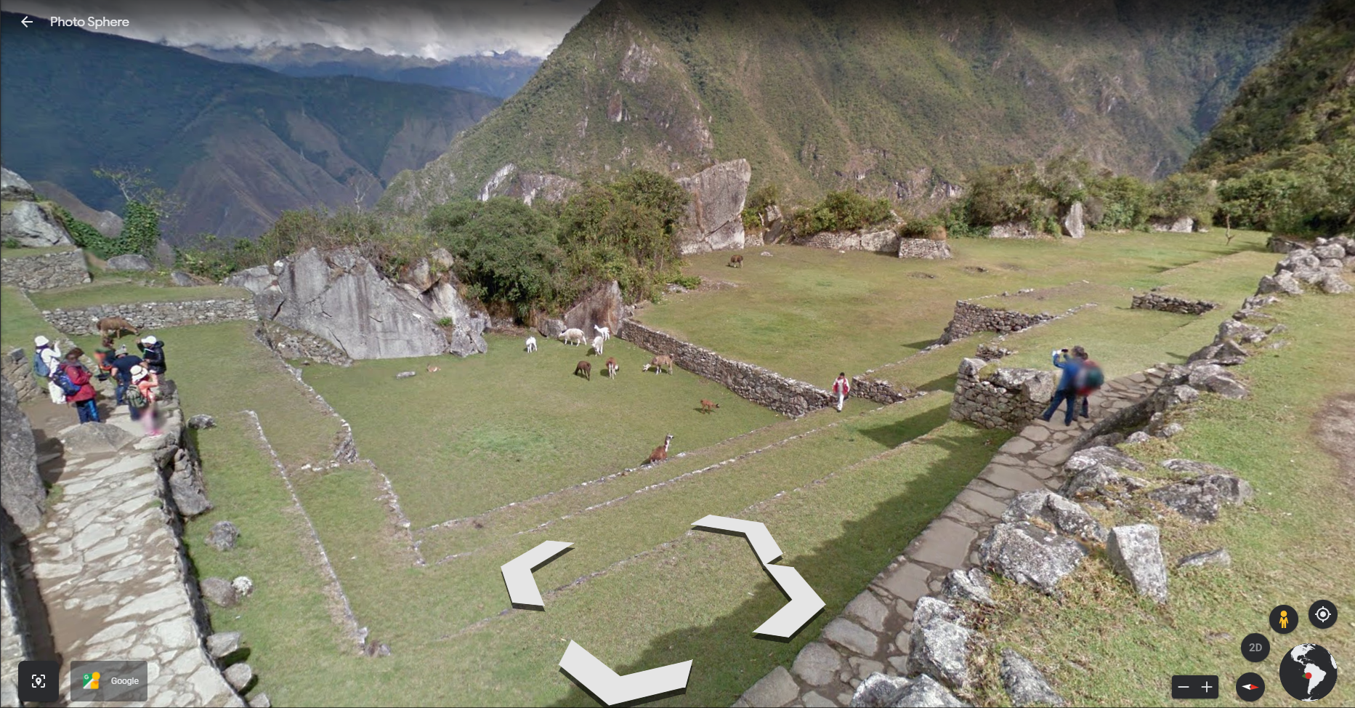
Image 2:
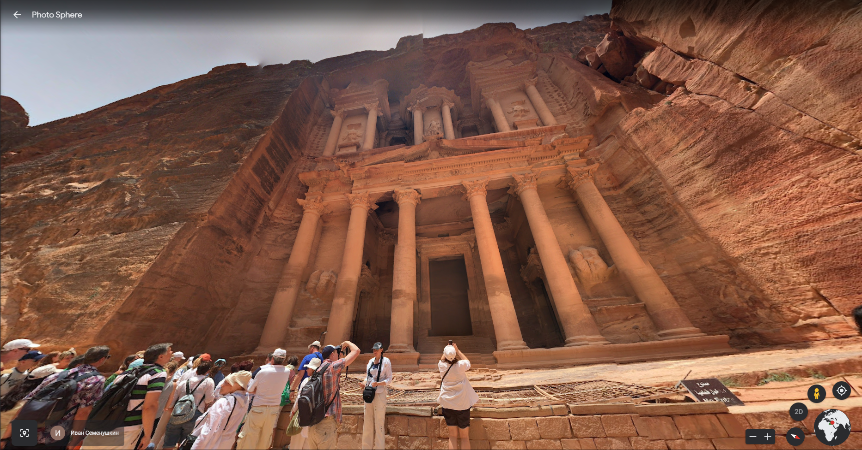
Image 3:
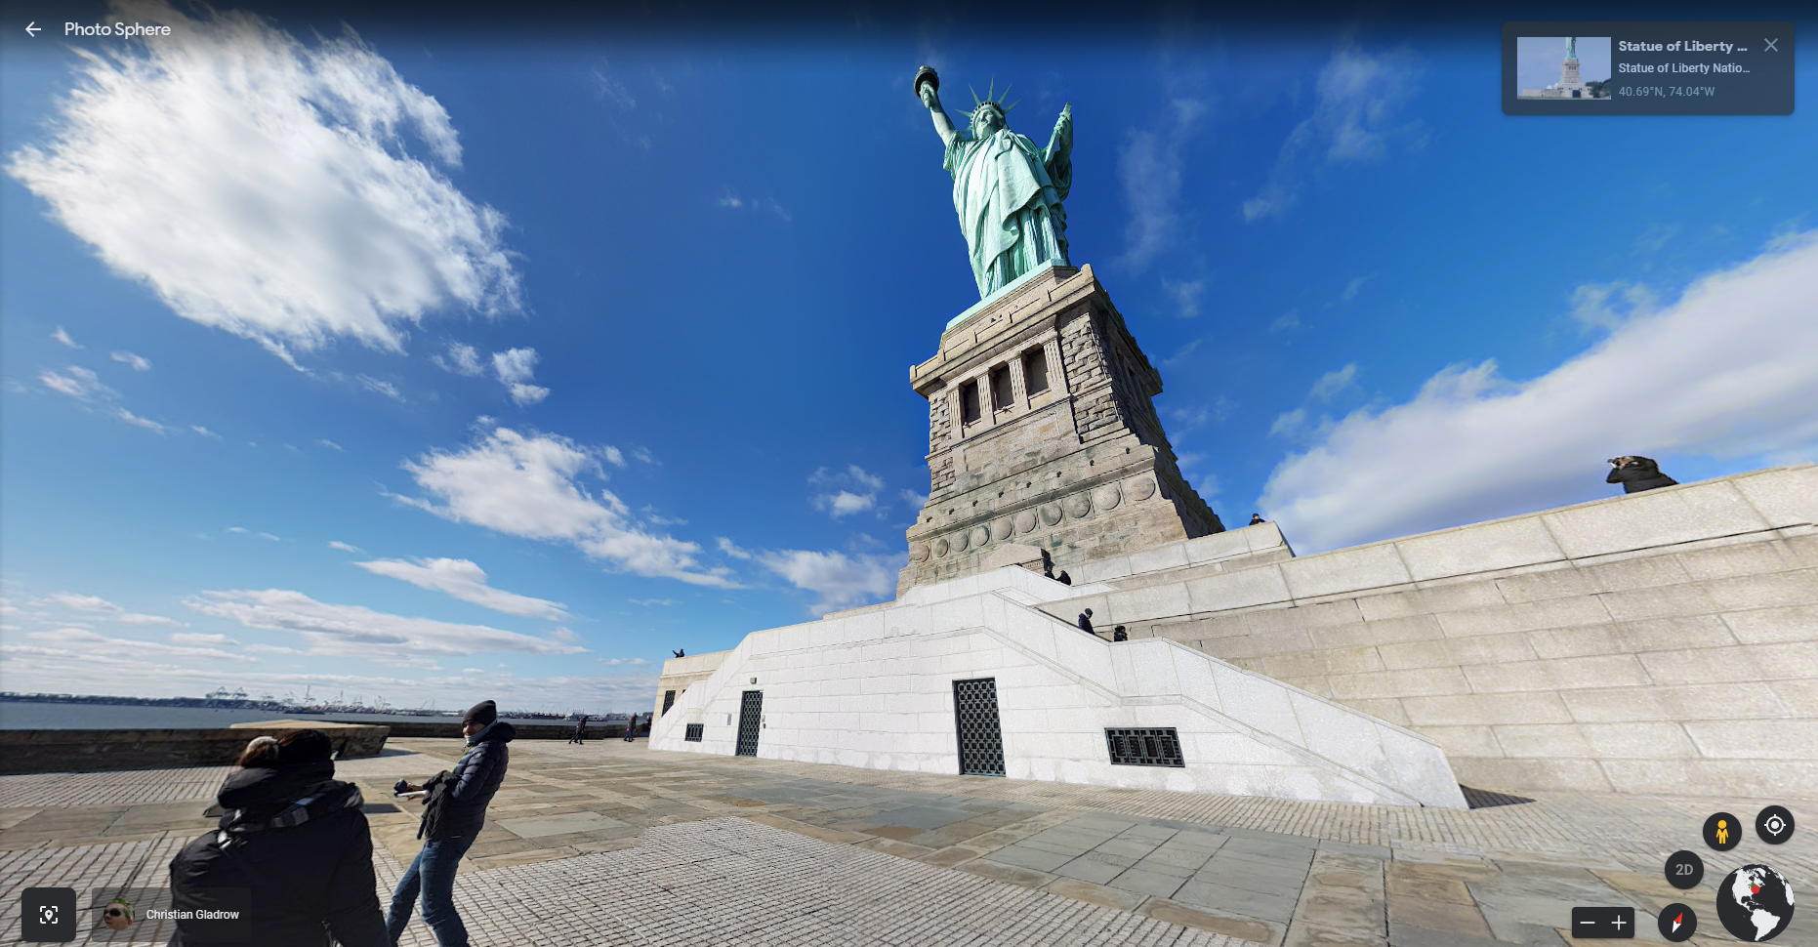
Image 4:
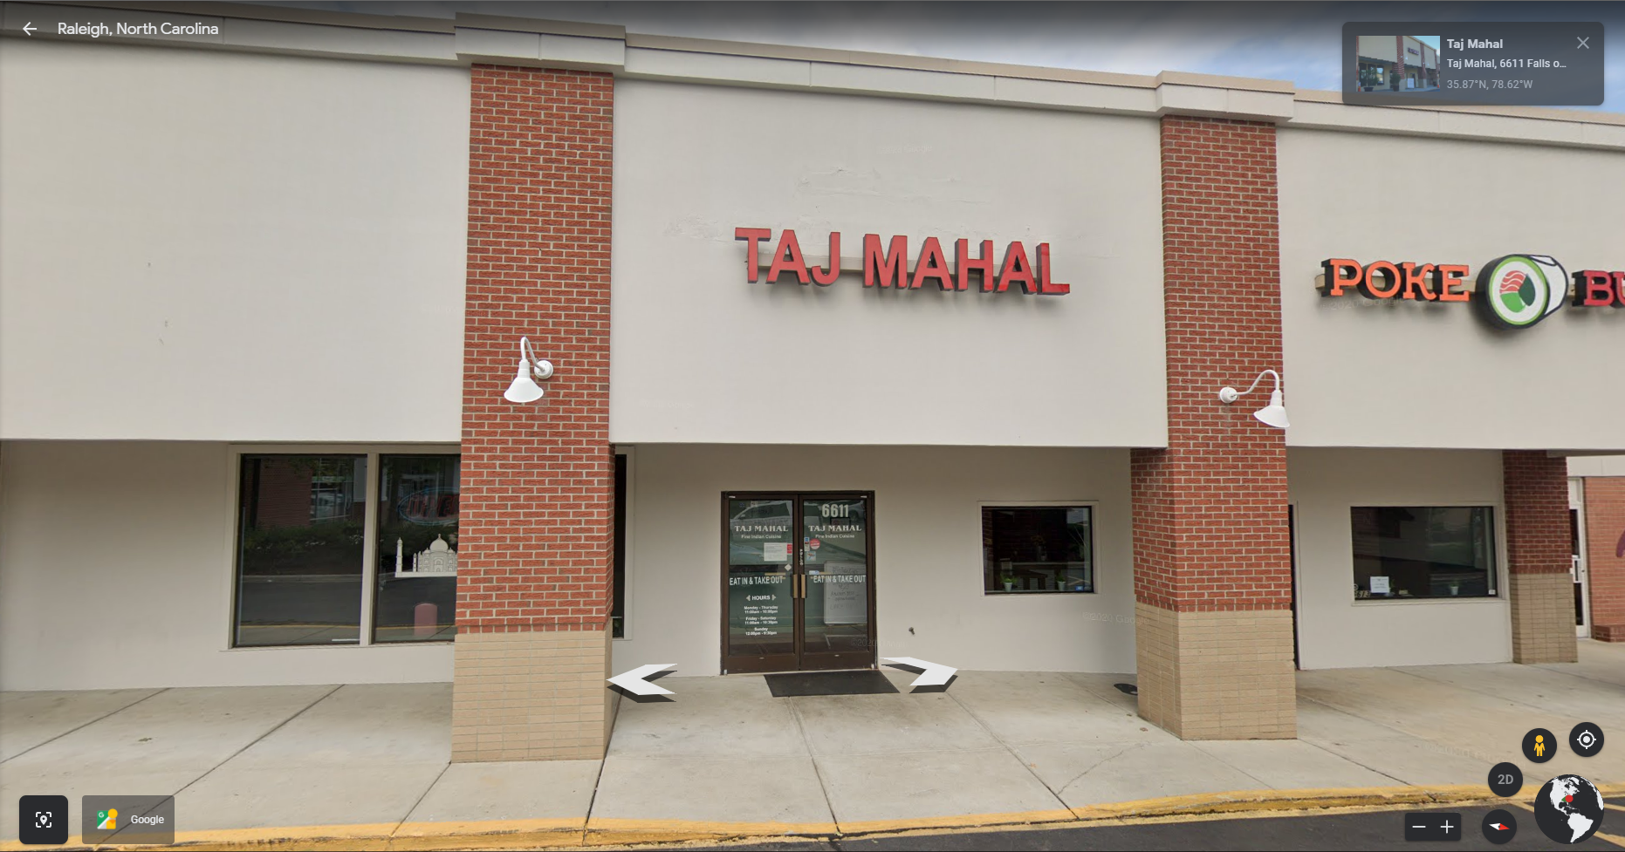

Image 5:
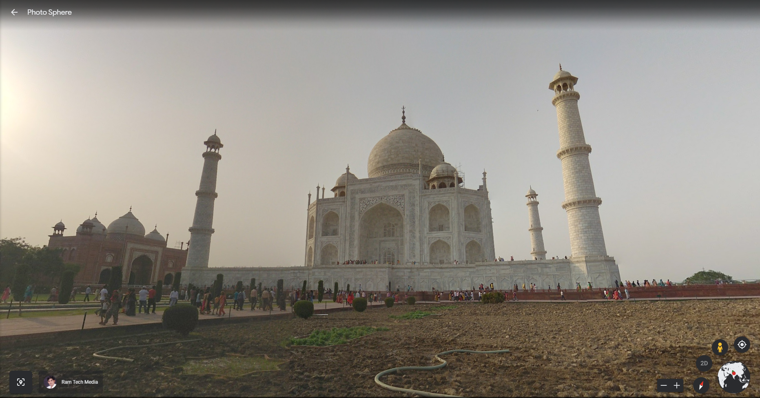
Image 6:
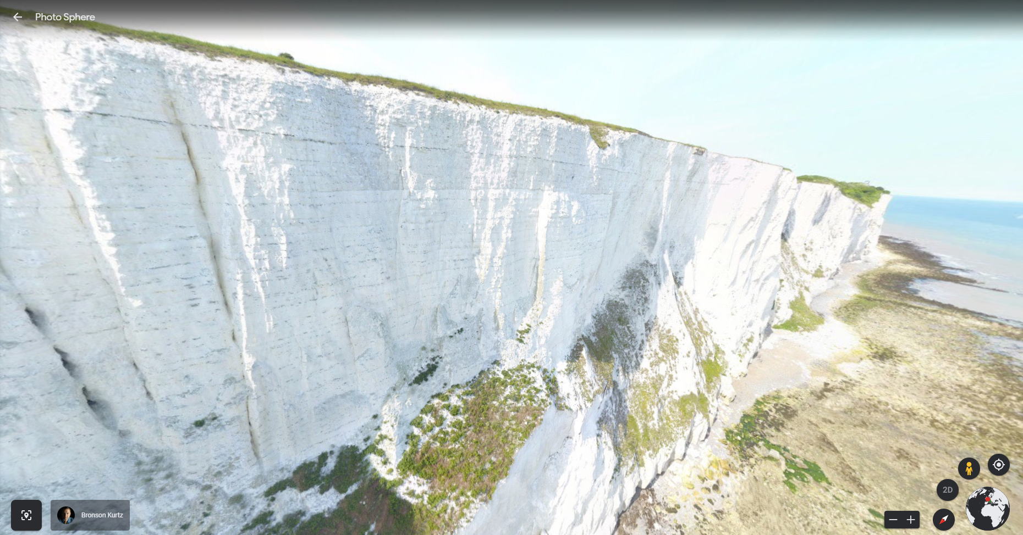

Image 7:
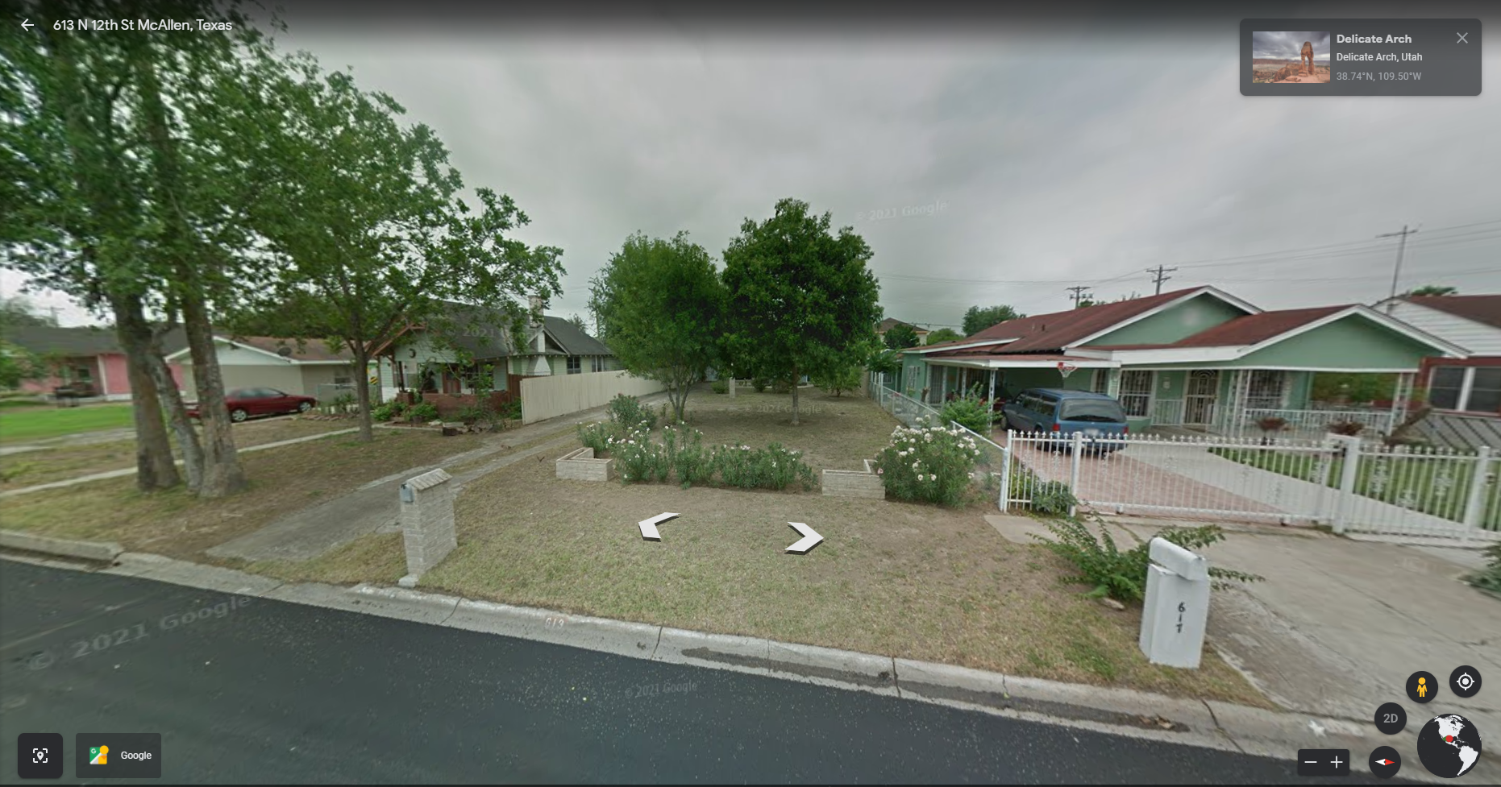
Image 8:
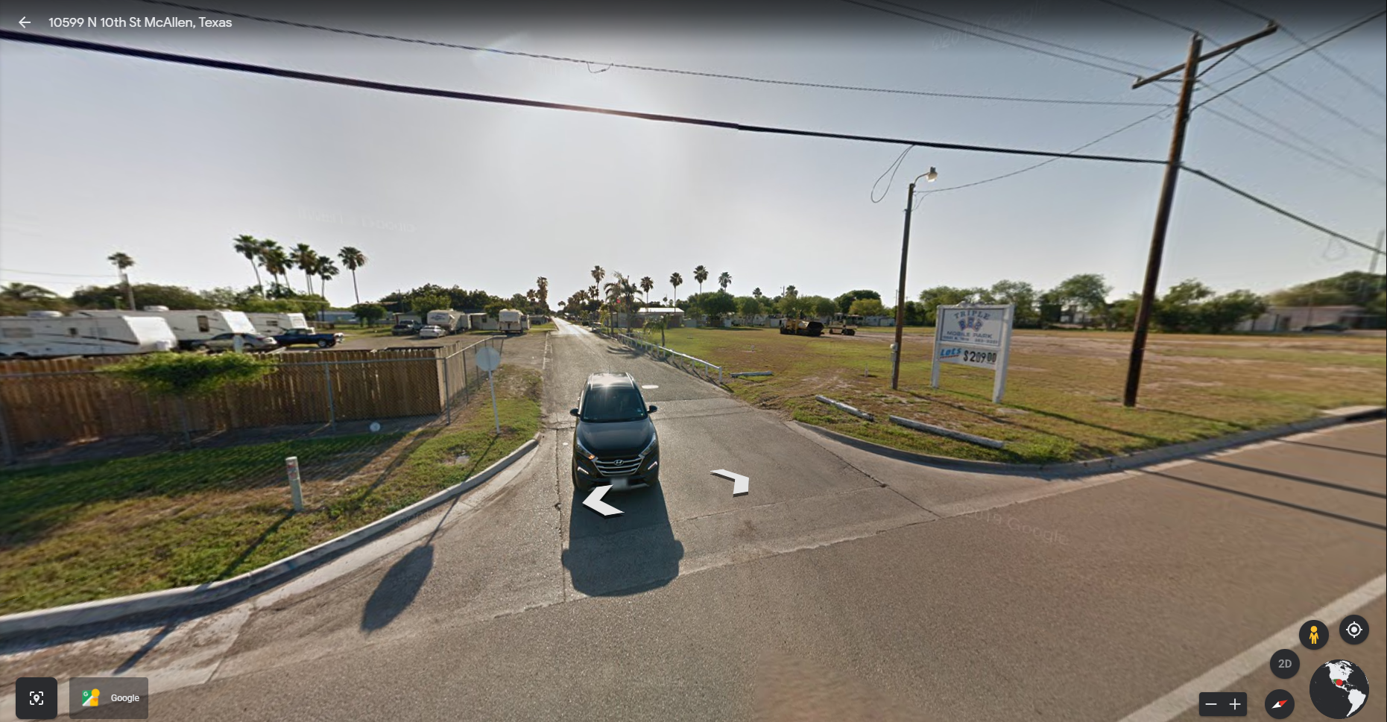

Image 9:
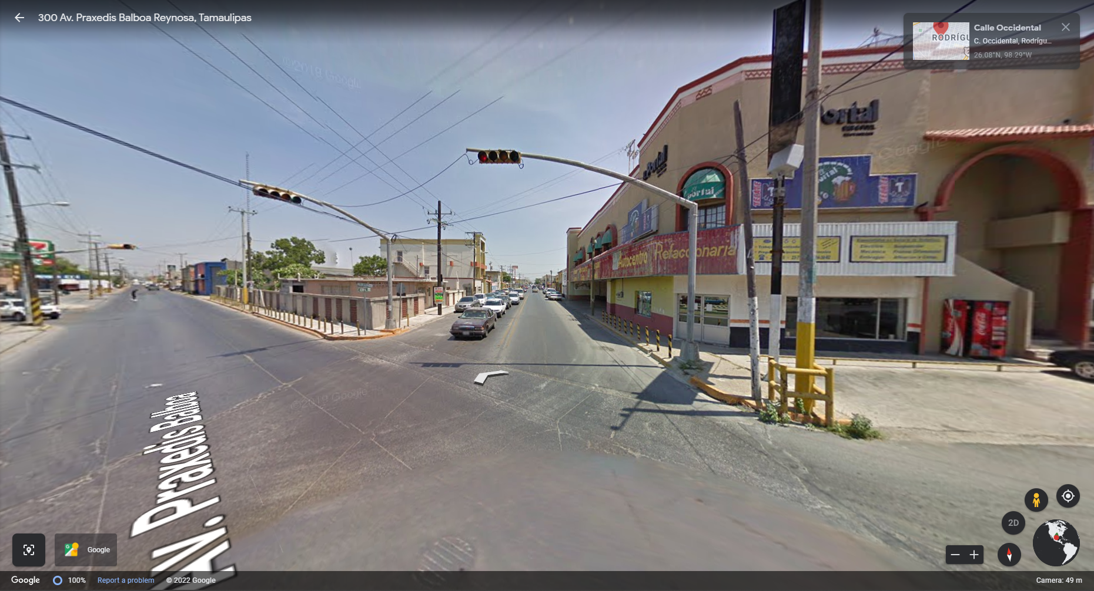
Image 10:
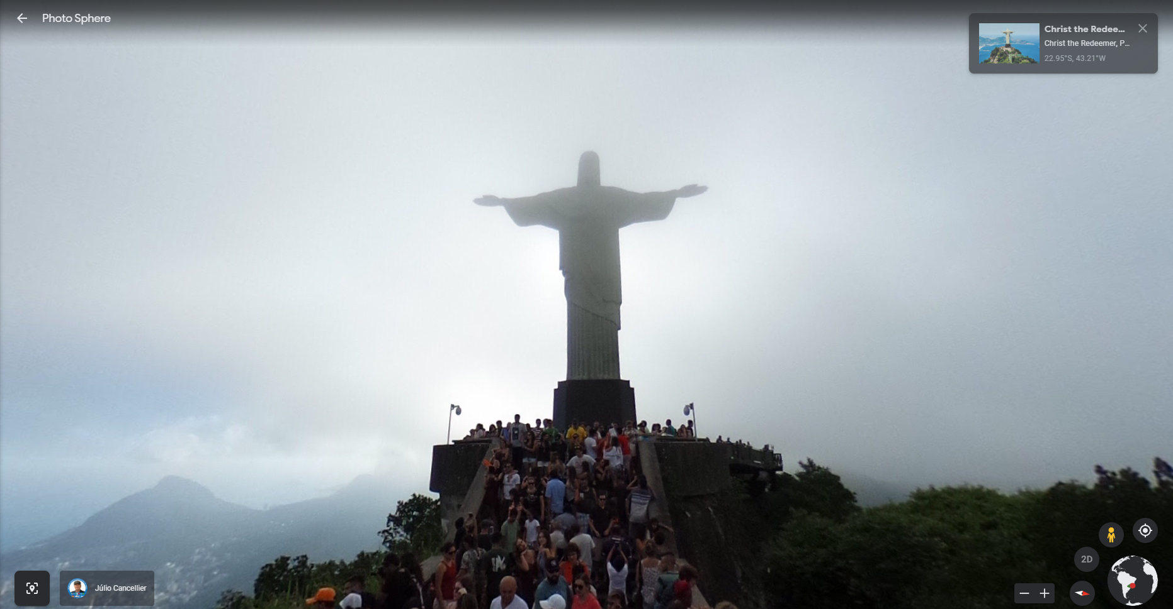

Image 11:
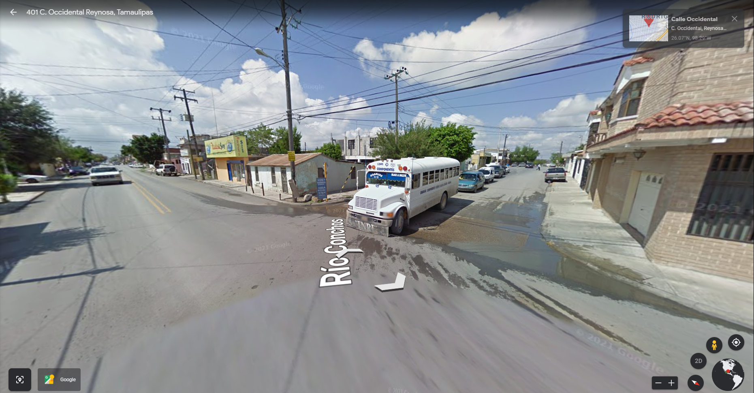

Image 1
Image 2
Image 3
Image 4
Image 5
Image 6
Image 7
Image 8
Image 9
Image 10
Image 11

